***Diocese of Kilmore***

***Safeguarding Newsletter* *September 2023***

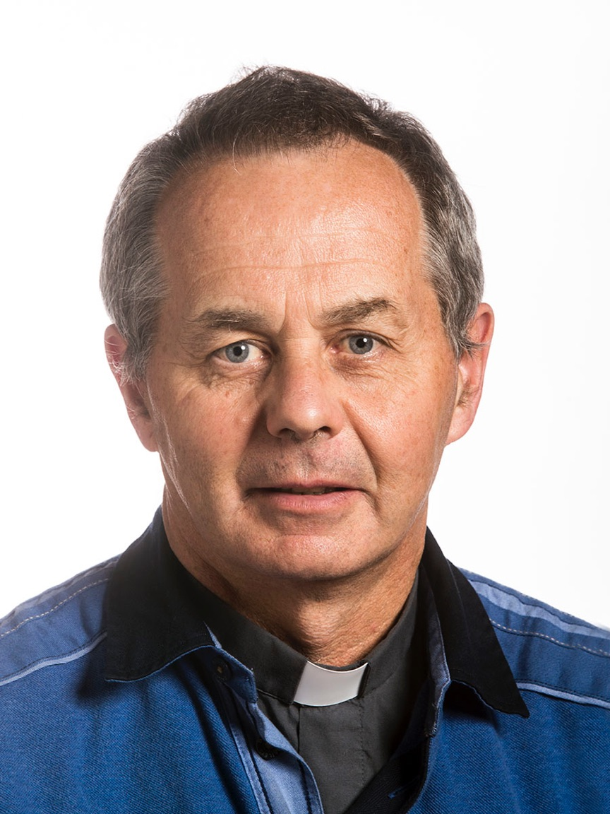Message from Bishop Martin Hayes

Safeguarding remains a priority for us in Kilmore Diocese. It is a priority within the overall mission to celebrate our faith inspired by the Gospel message of Jesus Christ and to reach out to all others, especially those in need.

Our faith is celebrated in our homes, schools and in our parishes, principally, in the gatherings for Eucharist on weekdays and in the main for Sunday Mass on weekends. It is vital that our gatherings for Sunday Mass at weekends offer the possibility of maximum participation of all present, e.g., Altar Servers, Readers, Ushers, Choirs, Eucharistic Ministers, Hospitality, all of whom are required to uphold our safeguarding policies and procedures. In thanking all who are actively involved in the celebration of our parish liturgies, I thank, in particular, our priests, sacristans and parish safeguarding representatives who ensure the celebration of our liturgies in accord with safeguarding standards. Also, in undertaking the essential work of responding to those in need we must ensure that all safeguarding protocols are observed.

This is the seventh Safeguarding Sunday in our diocese. It marks years of dedication and work by so many to ensure that the diocese is a safe place for children and vulnerable persons and for all those working with them. There are over 200 people voluntarily working on behalf of safeguarding across all our parishes. These include clergy, parish safeguarding representatives, parish leaders and volunteers, parish recruitment committees, chairs of parish pastoral councils, pastoral assistants, permanent deacons, diocesan advisers, Lourdes pilgrimage leaders, support persons, trainers, the diocesan committee for safeguarding, the advisory panel for case management, designated liaison persons and the diocesan director of safeguarding.

I am most grateful for their commitment and dedication to their safeguarding brief. It is greatly appreciated. Our parishes and diocese are safer places for young people to participate fully in the life of the Church. It is with great joy that I witness the involvement of so many young people through altar serving, children’s choir, children’s liturgy, faith friends, you shall be my witnesses, growing in faith together, the children of the Eucharist, young readers and the John Paul 11 awards.

As part of our Synodal journey, all twenty-six dioceses in Ireland sent a response to Rome last year. The very first theme addressed in the submission was ‘Abuse as Part of the Story of the Church’. It spoke of the hurt, the disappointment, the ‘open wound’ that abuse is and remains in the Irish Church. Victims and survivors of abuse will live with the pain for the rest of their days. Huge damage and hurt has been done. I want to acknowledge that hurt and pain and pray that God will heal and comfort anyone who suffered abuse within the Church. The Church offers support to victims and survivors through the services of Towards Healing and Towards Peace. Their contact details are included in this newsletter. The first Friday of Lent each year is dedicated across Ireland as a day of prayer for victims and survivors of abuse. Here in Kilmore, a special Mass is held annually on that day in the Cathedral and parishes throughout the diocese offer prayers for the healing of victims and survivors of abuse.

May we continue to give praise to God and find ways to put our faith into practice while ensuring the safeguarding of all involved in our parishes.

With prayerful good wishes.

+ Martin Hayes, Bishop of Kilmore.

Annual Safeguarding Sunday

Our seventh annual Safeguarding Sunday will be held throughout the diocese on the weekend of the 23rd & 24th of September 2023. The purpose of Safeguarding Sunday is to create a greater awareness of safeguarding in our parishes and to recognise the significant contribution of the faithful in ensuring that our diocesan safeguarding children policy and our diocesan adult safeguarding policy are being adhered to. Special prayers of the faithful and homily notes have been prepared and distributed to all the clergy for inclusion in the weekend liturgies.

Safeguarding Training Delivered

Seven full day training sessions, ten update information sessions, four recruitment trainings for chairs of parish pastoral councils, and two adult safeguarding trainings took place between September 2022 and June 2023. Further training days are scheduled to take place before the end of this year.

Reporting Procedure



Recruitment & Garda / Access NI Vetting

The legislation requires vetting of those who engage in 'relevant work or activities'. Included in this is "any work or activity as a priest or minister or any other person engaged in the advancement of any religious beliefs to children or vulnerable persons unless such work is incidental to the advancement of religious beliefs to persons who are not children or vulnerable persons".

Each parish has a safeguarding recruitment committee whose role it is to ensure that the diocesan recruitment procedure is adhered to within the parish. Any person who wants to or is asked to be involved in ministry (relevant work or activities) with children or vulner­able persons **must** be recruited by the parish recruitment committee (in accordance with the diocesan recruitment procedure) and be subject to Garda or Access NI vetting. Only people actually working with, or supervising children or vulnerable persons are to be vetted.

Examples of people who are not required to be vetted are ushers, collectors, flower arrangers and sacristans who do not supervise altar servers. Sacristans who do supervise altar servers are required to be vetted. Training has been provided to the parish recruitment committees, so they will know who requires vetting and who does not. If contact with children is not planned, such as a situation where children enter the church when a church activity is taking place, that contact is incidental and does not lead to a requirement for vetting.

Garda re-vetting is every 3 years. It is **unlawful** for anyone to enable or permit any person to be engaged in relevant activities with children or vulner­able persons without being subject to Garda or Access NI vetting.

Visiting Clergy

The Diocese of Kilmore warmly welcomes all visiting clergy wishing to take part in public ministry. Bishops, priests and deacons are required, on request, to produce a valid Celebret. Before a visiting priest can minister in the diocese, they must first:

**√** have permission from Bishop Martin Hayes.

**√** complete a Declaration of Good Standing.

**√** be Garda/ Access NI Vetted.

**√** have attended Safeguarding Training.

**√** hold a valid Celebret.

How the Kilmore Diocese Reviews Safeguarding Practice

**√** 3-year Strategic Safeguarding Plan.

**√** Parish Support Visits.

**√** Annual Parish Audits.

**√** Annual report by the DLP to Bishop Martin Hayes.

**√** Annual report by the Director of Safeguarding to Bishop Martin Hayes

regarding compliance with the seven standards of Safeguarding.

**√** Notification in writing to the National Board for Safeguarding Children in the Catholic Church in Ireland regarding case management and compliance with the seven standards of Safeguarding.

Guidance on Private Functions using Church Property

Church property is primarily for use for Church sponsored activities and as such has insurance to cover the property and the activities organised by the parish/ diocese. Such activities include:

• Ministry with children that is organised by the parish/ diocese as part of sacramental celebrations (for

example a Communion or Confirmation celebration involving a number of children). In these situations,

the responsibility for safeguarding rests with the parish/diocese.

• Parish/diocese related events that are under the direction and control of the parish priest/diocesan office.

In these situations, the responsibility for safeguarding rests with the parish/diocese.

• Parish school activities. In these situations, it is advisable that the school and the parish agree who is

responsible for safeguarding using the Kilmore Safeguarding Agreement Between Parish and School.

Individual adults (parents/guardians/family members) may approach the parish priest to seek use of Church property for a private function with children (e.g. children’s birthday party) outside of the activities listed above. Such activities will not be covered under the Church’s child safeguarding procedures or the Church’s insurance cover. Inherently there will be risks associated with such activities that the Church should not accept responsibility for, and therefore letting the property for such one off events will not be permitted.

Feedback

Feedback on our present safeguarding arrangements is always welcome and you are encouraged to do so. Each parish holds an annual safeguarding information session at which feedback on our safeguarding practices is sought from those who attend. Please give your feedback, thoughts and suggestions during these information sessions. The parish safeguarding representative will forward them to the diocesan safeguarding office. You can also give your feedback directly to the diocesansafeguarding office by contacting Suzie Duffy at safeguarding@kilmorediocese.ie

Towards Healing

Towards Healing is an independent organisation providing free professional support for people who have experienced institutional, clerical or religious abuse in Ireland. It provide face to face counselling, structured phone counselling, family counselling and a counselling helpline.

Tuesday to Friday: 9.00am - 5.00pm.

Freephone: 1800 303416

Hearing Impaired Text Line: 085 8022859

Email: info@towardshealing.ie Website: www.towardshealing.ie

Towards Peace

Towards Peace provides spiritual support in a safe supportive space, where people who have been affected by

abuse in a Church context can be accompanied as they seek their own experience of spiritual peace, one step at a time.

Monday and Tuesday: 9.00am – 4.00pm

Wednesday: 9.00am -12.00 noon

Phone: 01 5053028 / 086 7710533

Out of Office Hours: 086 7710533

Email: towardspeace@iecon.ie

Website: www.towardspeace.ie

**If you have a safeguarding concern or wish to raise a matter from the past, you may contact any of the following. A concern can also be about someone who has been** **abused and their abuser is now deceased.**

*Kilmore Diocese:*

Suzie Duffy,

Kilmore Diocesan Pastoral Centre, Cullies, Cavan, Co. Cavan. 049 4375004, ext 105

Email: safeguarding@kilmorediocese.ie Website: www.kilmorediocese.ie

Paul Cullen,

Kilmore Diocesan Pastoral Centre, Cullies, Cavan, Co. Cavan. 049 4375004, ext 109

Email: safeguardingdlp@kilmorediocese.ie Website: www.kilmorediocese.ie 085 2578490

*An Garda Síochána:*

Detective Superintendent Ian Lackey,

S.C.M.U., Garda National Protective Services Bureau, Navan Road Cabra West, Dublin 7. D07 TW80

Email: GNPSB_SCMU@garda.ie 01 6663903

*PSNI:*

20 Queen Street, Enniskillen, Co. Fermanagh. BT74 7JR 101 (non-emergency)

Online reporting: www.psni.police.uk/advice_information/child-protection/ 999 (emergency)

*Tusla:*

Child and Family Agency, Hampton Court, Cootehill Road, Cavan, Co. Cavan. 049 4369800

Health Care Unit, Rooskey, Co. Monaghan. 047 30400

*HSC:*

Gateway Team, Derry: 028 71314090 (from NI), 048 71314090 (from ROI)

(Mon - Thurs: 9.00am - 5.00pm, Fri: 9.00am - 4.30pm)

*NBSCCCI:*

National Office for Safeguarding Children,

New House, St Patrick’s College, Maynooth, Co. Kildare.

Email: admin@safeguarding.ie 01 5053124